To do

1) maybe add some revealed preference history on binary choice stuff – see mark’s thesis intro
2) make plot axis text bigger
3) properly name sections and format titles etc
5) horowitz equation 2.3
6) add little intro sections to econ parts for neuro guys?

Notes to reviewers:
This chapter in the thesis:
In this chapter the aim is to convey 4 main things:
1) commonly econ experiments and esp animal econ experiments rely on binary choice paradigms which are generally fine but have some problems
2) these problems are overcome by using the bdm paradigm
3) this is how the bdm works/ why it works/ maths stuff
4) some people have done fmri of bdm heres what they found
Its kind of like an intro chapter part 2 but also starting to bleed in some theoretical results (nothing novel but still stuff that useful to keep in mind when thinking sbout the bdm as a task)
It acts as a bridge to chapter 3 which is where I discuss our behavioural results of the monkeys on the BDM (n.b. throughout this chapter I try to use ‘participant’ or ‘subject’ as of course there are human studies of auctions so might be worth keeping an eye out for if/where I slip up)
Things I don’t care about:
- Chapter/equation/appendix numbers and titles / page layout – these can be done last when putting everything together
- Again, some terms in the equations might not be the best way of representing some quantities. Worth pointing out if the maths doesn’t work or if something looks bad but not too important yet.
- Graphs etc axis text. Ill make it bigger but that can be done last
The only thing I really care about is that people understand what a BDM auction is and how they work (maybe not mechanistically but at least that someone makes a bid and wins paying the second price and why it is the second price). You (hopefully) should leave the chapter thinking “this is a good task for an experiment because xyz”.
Chapter 2 – Auction Theory as a Neuroscientific Tool

One problem that studies of economic decision-making face is that utility is an internally generated value and must be reported by any animal or human subject to an external observer. The context a subject finds themselves in is a key constraint on how easily and accurately an experimenter can measure a participant’s utility. Therefore, choosing an adequate task for any animal or human is of the utmost importance.

Making invasive recordings from a model organism is both time consuming and requires the sacrifice of animals. It is vital that experiments are designed to generate the most pertinent and robust findings possible given these costs. As expressed by Niv, 2020, “arguably, the most interesting findings from neural recordings or perturbations are […]coupled with incisive, hypothesis-driven behavioural experimental designs.” The key differentiating aspect of this thesis is its choice of behavioural paradigm for electrophysiological recording. Instead of using repeated binary choices made by an animal, we record from non-human primates performing an auction task. The focus of this chapter is to describe the importance of this difference, and the nuances of the task.

What makes a good economic task?

When using an economic task as an experimental paradigm, it is crucial that the task should reveal the mechanisms used by the subject to make economic decisions. For instance, a game of roulette using a fair (random) wheel where the subject can pick one number on which to place a bet cannot reveal anything about how the subject makes economic decisions. Each possible choice the subject can make has the same expected payoff and so no choice exists that has any more value than another.

If we then allow the roulette player to pick how to spread their bets, the task presented is still inherently random (there is no ‘winning strategy’ to roulette), but we have allowed the subject to alter the expected utility of a trial. A player who routinely spread bets thinly is risk averse, preferring a higher chance of small wins, compared to one who places it all on one number, seeking large (risky) gains. This task is now suitable for use in understanding a subject’s risk preferences, and how and why these change as they complete multiple rounds of the task.

In contrast, if there are too many potential strategies for a task, it is also difficult to glean any understanding of how a subject makes decisions. For instance, in a round of poker any player who bets high may hold a hand they subjectively value, or be bluffing on a poor hand. There is no incentive for the player to truthfully reveal the value of their hand, as doing so would allow opposing players to exploit them. As there is no rule that a poker player must state which strategy they are using, there is no way for would-be economists to know exactly the subjective value placed upon the cards drawn.

It is crucial that any task used to reveal a subject’s valuation of a chosen option is incentive compatible. I.e. it is always in the best, selfish, interests of any participant in the task to truthfully reveal exactly their preferences, or valuation, of the presented options. This is doubly important in any animal models of economic decision making where the strategies available to an animal cannot be verbally explained and must be learnt via reinforcement. The strategy the animal settles on should always converge to the one which yields the maximum rate of subjective value returned.

Any task suitable for research into economic behaviour therefore should have a single, obvious strategy which is incentive compatible. A self-interested participant in the task should always follow this utility-maximising strategy, which is referred to as the dominant strategy. This should override any internal desire for (e.g.) a nefarious human participant to deceive the experimenter about their valuation of a presented option allowing us to be confident that a choice truthfully reveals their preference.

In traditional ‘binary choice’ paradigms outlined in the previous chapter (see figure 1.1 and also Mosteller & Nogee, 1951), choices are obviously incentive compatible as any participant should always choose the one which presents the greatest expected utility. For a simple riskless choice between two quantities of the same desired good ($A$), a subject should always have more utility for the option that contains more of the good, and thus preferentially choose that option.

However, a single trial of a binary choice task never reveals exactly the value of one option in terms of the other. A subject can only choose between options, and not in terms of them. A simple experiment that offered a participant an amount $X$ of good $A$, and an amount $Y$ of good $B$ only reveals which has the higher valuation, and not the values of $X$ and $Y$ for which $X×A == Y×B$.

To calculate the numeraire- the quantity $X$ for which $Y$ is equal to 1- repeated choices between amounts of goods $A$ and $B$ are required. As valuation decisions (like all types of decisions) are noisy and even sometimes erroneous, a binomial function can be fitted to the choices. The midpoint of this logistic function can be taken as the indifference point, the values of $X$ and $Y$ for goods $A$ and $B$ where a subject is indifferent between the choices. I.e. both choices represent the same utility. Therefore, the equation $X×A == Y×B$ is satisfied, and the values of $X$ and $Y$ can be derived and rearranged to calculate the value of good $A$ in terms of a numeraire $B$.

However, the nature of such a repeated measures task has three obvious limitations:
- As the indifference point is interpolated, it is not uncommon for there not to be any choices made at the point where $X×A == Y×B$. The indifference point is an estimate, not a truly observed equality. In addition, any errors in calculating the logistic fit over the observed points will lead to errors on this estimate.
- To minimise this error, binary choice tasks require many trials to reduce the noise on any one repeated measure. Given a subject will only complete so many trials, in any binary choice experiment, the experimenter must trade-off the resolution of the probability of choices for any offer, and the number of different options to present.
- As the experimenter increases the number of trials required from a subject, they also increase the time taken by a subject to complete a session. Holding the rewards for completing any single trial constant, this means that the subject may become more ‘sated’ with the payment from the task over time and the marginal utility of later trials will be lower than on identical earlier trials. Even if they do not, participants bidding may chance as the novelty of the task wears off. In order to calculate utility, the average choices over a range of trials must be used and it must be assumed that the probability of choice between any two options remains constant over this range.

Examples of these 3 limitations are shown in figures 2.1a-c. For a real-life example, consider figure 2.7 which is redrawn from Mosteller & Nogee’s attempt to measure the utility of monetary bets (Mosteller & Nogee, 1951).

Ideally, we would use a task in which on every trial the subject states their exact subjective value of $X$ for a given offer of $Y×B$, that is, a subject would state their willingness-to-pay in terms of $X$ for an amount $Y$ of good $B$. Such tasks exist using auctions such as the Becker-DeGroot-Marshak (BDM) auction task which has been extensively studied by experimental economists researching human decision making.

A single trial method to measure utility

The concept of the BDM was first defined in a 1961 theoretical paper by William Vickrey (Vickrey, 1961), but takes its name from the authors of a 1964 paper in which human subjects were given wagers with the chance to win $\$W$ in the case of an event $p$, and $\$L$ otherwise $(1-p)$ where $\$W$ is greater than $\$L$ (Becker et al., 1964).

For each of these wagers, the subjects were asked to give a price $\$X$ which is the lowest amount of money they would accept to sell the wager. This price is the subject’s willingness to accept (WTA) and is clearly a function of the value the subject places upon the wager given to them. After, a random number representing a buyer’s bid $\$Y$ is drawn, and if this number is greater than the participant’s WTA $\$X$, the subject receives $\$Y$ dollars, otherwise the wager is resolved and the subject wins either $\$W$ or $\$L$ depending on the outcome.

This WTA value can also be described as the subject’s certainty equivalent. It is the amount (in this example the monetary selling price) of a good they are content to receive with complete certainty. For a utility maximiser, they should only be satisfied so long as the utility of the CE is equal to the utility of all possible outcomes ($O$) of a trial multiplied by their probability.

Equation 2.1
$$υ_{i}(CE) = p_{1}⋅υ_{i}\left(O_{1}\right) + p_{2}⋅υ_{i}\left(O_{2}\right) + p_{3}⋅υ_{i}\left(O_{3}\right) + ...p_{n}⋅υ_{i}\left(O_{n}\right) =υ_{i}(\$X)$$

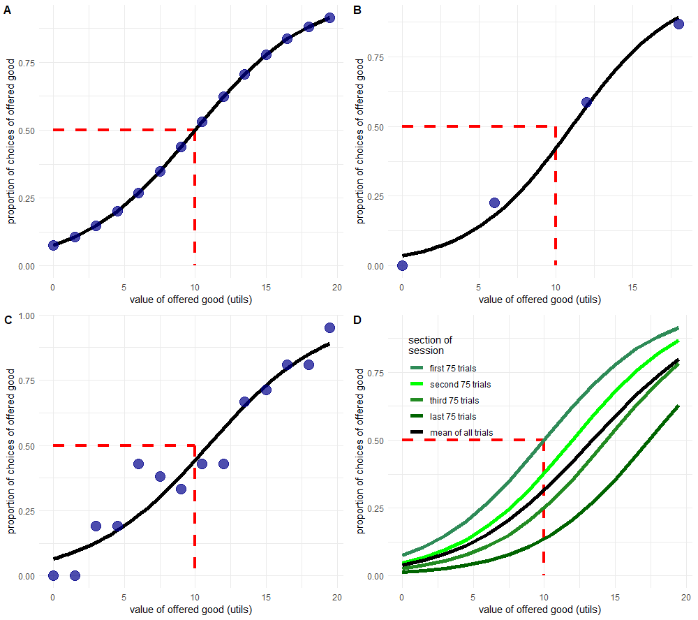
Figures 2.1a-d): The repeated binary choice paradigm has multiple undesirable features. All four figures show a simulated indifference curve (black) of hypothetical choices between a sure 10 utils and an offered good whose utility varies from 0 – 20 utils. We assume that the ‘true’ indifference point of a participant is when they must choose between the sure 10 utils and an offered 10 utils (dashed red line at 50% proportion of choices). Figure 2.1a) shows average choices (blue circles) which follow a perfect logistic distribution, though with an indifference point that is not directly sampled by the offered choices. Figures 2.1b) and 2.1c) show the constraint of 300 trials (a reasonable session for a trained non-human primate) where a researcher is faced with a trade-off between maximising accuracy by reducing the number of distinct choices (2.1b) or precision by reducing the number of choices made at each distinct offered choice (2.1c). Figure 2.1d) shows a hypothetical effect of satiety on the choices of a participant, where the value of the offered good decreases by 15% relative to the sure 10 utils after each block of 75 trials.
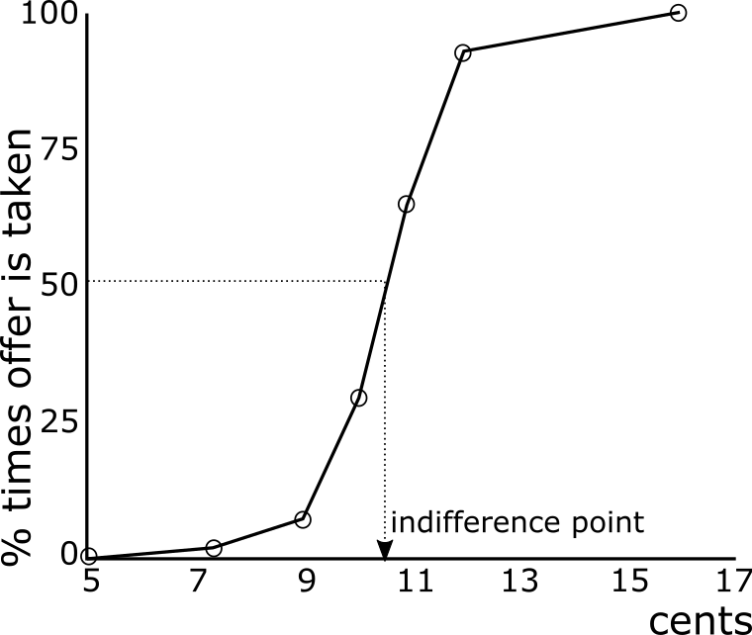
RENUMBER FIGURE Figure 2.7) In empirical studies of utility it is not uncommon to find indifference points at unobserved choices. Redrawn from Mosteller and Nogee, 1957, in which subjects were offered the chance to make a bet with a cost to enter of 5₵. The utility curve for a single subject here (figure 2 in the original paper) shows the percentage of times the bet is made for fixed odds. The assumed indifference point of ~10.5₵ in this case is never directly tested with an offer, highlighting a weakness of the binary choice paradigm.
Where $υ_{i}$ is the utility a single subject places upon each outcome. In the wager selling task with two potential outcomes (win the bet with probability $p$, or lose with probability $1-p$) this resolves to

Equation 2.2
$$υ_{i}(CE) = p_{w}⋅υ_{i}\left(W\right) + {(1 - p}_{w})⋅υ_{i}\left(L\right) =υ_{i}(\$X)$$

In a reversed task where participants bid for an auctioned good, it should be clear that the certainty equivalent, in this case a willingness to pay, should remain the same for each participant as on each trial the participant can either win or lose the auction with a probability $p$ or $1-p$. The reverse of selling a wager for at least as much as a price $\$X$, is the same as buying entry to that wager with at most a price $\$X$. The randomly drawn buyer’s offer $\$Y$ is in this case a randomly drawn second buyer’s price $\$Y$ which the subject pays.

This is equivalent to a sealed second price auction, in which the participant who bids highest for a good, wins the auction and pays the second highest bid to obtain their reward. All other participants neither pay nor win anything.

In such a sealed second price auction, the weakly-dominant strategy is always to bid exactly the value of the good being auctioned. A participant who follows this strategy will never have any ‘regret’ about their bid; there exists no bid that could yield more utility from the trial. In contrast, all other potential bids have the potential for such regret by either yielding negative utility (overpaying for the reward), or net zero utility where the possibility of positive utility was present. This is a counterintuitive finding but is explained in figure 2.2 and in the paragraph below:

Imagine a subject $S_{1}$ bidding against $S_{2...n}$ other participants. The true exact utility of a good to be auctioned to subject $S_{1}$ is $G_{1}$ and the maximum utility of $n$ other participants for the good is ${\hat{G}}_{n}$.

Across trials, a rational participant may win or lose auctions depending on whether $G_{1}>{\hat{G}}_{n}$ or $G_{1}<{\hat{G}}_{n}$ (we assume utilities are continuous and never exactly equal to each other). When $G_{1}>{\hat{G}}_{n}$, the subject wins the auction and pays ${\hat{G}}_{n}$. By definition, $G_{1}>{\hat{G}}_{n}$, so the subject makes a profit of $G_{1}- {\hat{G}}_{n}$.

When${ G}_{1}<{\hat{G}}_{n}$, the participant neither wins nor pays any money, and so makes no profit or loss (except perhaps a small waste of time).

Having failed to win in multiple trials and becoming bored of losing, let us assume that the subject decides to raise their bid to $H_{1}$, where $H_{1}> G_{1}$.

On trials where $H_{1}<{\hat{G}}_{n}$, they lose the trial and make neither a profit nor a loss. Given that ${G_{1}<H}_{1}<{\hat{G}}_{n}$, they would have lost this trial in any case had they bid their true value.

However, in the case where $H_{1}>{\hat{G}}_{n}$, they still pay ${\hat{G}}_{n}$ but may make a profit or a loss:

If ${\hat{G}}_{n}<G_{1}<H_{1}$, they make the same profit as with their previous strategy:$G_{1}- {\hat{G}}_{n}$.

However, where $G_{1}<{\hat{G}}_{n}<H_{1}$, the change in utility to the subject is still measured as $G_{1}- {\hat{G}}_{n}$, but this will be negative; $S_{1}$ makes a loss on the trial.

Having been burned with the strategy the increase bids, the subject instead tries to underbid for the reward. They bid $I_{1}$ where $I_{1}< G_{1}$.

Now they may still win any single trial where $I_{1}>{\hat{G}}_{n}$, but given that
${\hat{G}}_{n}<I_{1}<G_{1}$, they still only make a profit of $G_{1}- {\hat{G}}_{n}$.

But, as $I_{1}< G_{1}$, on any trial where $I_{1}< {\hat{G}}_{n}$, they lose the trial and miss out on the chance to make a profit of $G_{1}- {\hat{G}}_{n}$ in the case that $I_{1}<{\hat{G}}_{n}<G_{1}$.

In summary, we are forced to conclude that subject S₁ will never regret bidding their true utility of a reward ($G$), but if they do not bid their true utility they may sometimes regret overpaying or missing out on the opportunity for profit.

Each of these eventualities are shown in figures 2.2a-h) where bids and values are represented as bars across a continuous number line and a higher position indicates a higher bid/value. It should be mentioned that in experimental trials of the BDM, the subject is generally given a budget to spend or keep so the utility of losing a trial is not exactly zero as it might be for BDM auctions ‘in the wild’. For sake of simplicity however, losing an auction and receiving the budget is treated as the neutral outcome.

Bidding one’s true value is therefore weakly-dominant- a participant cannot do better than bidding their true value. We would therefore expect any rational utility-maximiser with a full understanding of the task to bid as close to their true value as possible for any good in a BDM auction. That is, it is in the best interests of any subject to aid the experiment by declaring their true utility for an offered good in any trial. A more comprehensive proof of this is presented in appendix 2.1, adapted from Milgrom & Weber, 1982.

The BDM as an economic tool

The first documented use of a BDM style auction predates the Becker experiment by 150 years. In 1797 the famous German poet Wolfang von Goethe wished to sell a newly penned epic poem Hermann and Dorothea. In 18th century Germany, authors sold the whole rights to a piece directly to publishers, rather than receiving payment per unit sold; the rights to the poem are equivalent to a good sold in an auction.
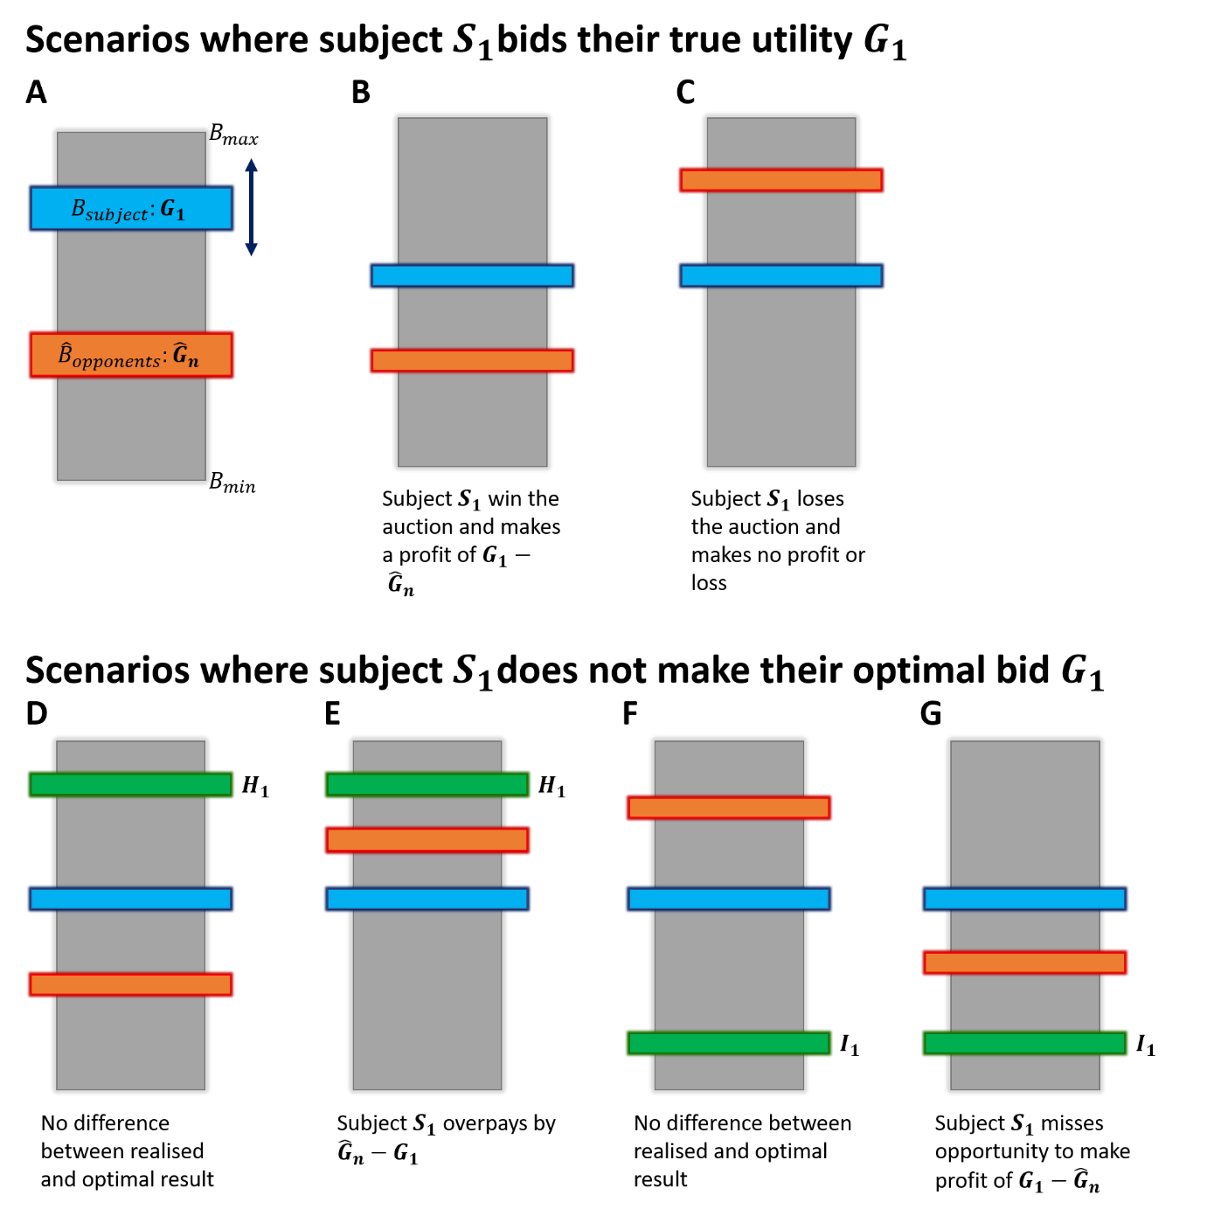
Figures 2.2a-g): The optimal strategy in a sealed-second price auction such as the BDM is to bid one’s true utility. In a hypothetical bidding range between $B_{min}$and $B_{max}$ (represented here as a grey bar, for comparison with the task we present to monkeys in chapter 3), a subject $S_{1}$has a utility for an auctioned good that is equal to $G_{1}$ (blue bar in a) and in subsequent panels). A subject can place their bid anywhere along the bidding range, but optimally should bid their utility for the auctioned good. In b) the subject’s bid is equal to $G_{1}$which is higher than the highest opposing bid ${\hat{G}}_{n}$(orange bar), so the subject wins the auction and pays the ‘second-price’ (${\hat{G}}_{n}$). In c) the subject makes the same, optimal bid of $G_{1}$but this is lower than the largest opposing bid, so the subject does not win the auctioned good but keeps their entire endowment. In d-g) the subject deviates from their optimal bid of $G_{1}$(blue bar as previously) to raise their bid ($H_{1}$, d-e)), or lower their bid ($I_{1}$, f-g)), represented by a green bar. In d) raising one’s bid has no effect on the outcome, but in e) we can see that this means risking overpaying for the good when $H_{1}>{\hat{G}}_{n}>G_{1}$. In f-g) the subject decides instead to lower their bid to $I_{1}$(green bar again), which has no effect on the outcome when the subject loses the auction, but gives rise to the possibility of missing out on profit when $G_{1}>{\hat{G}}_{n}>I_{1}$.
Already rich and declaring himself to be uninterested in purely maximising profit, Goethe instead wished to get as good an approximation of the true value of his work. He decided on a minimum acceptable price (his WTA, $\$X$ to compare with Becker et al. 1964) which was given to a legal counsel, Herr Boettiger. He then wrote to his publisher with the contents of the poem and the terms of the auction: if they offered a price ($\$Y$) which exceeded this reserve then he would accept their offer and receive $\$Y$ in exchange for the poem. If, however, $\$Y$ was less than the $\$X$ reserve price, then the negotiation was deemed a failure and Goethe kept the rights to the poem to be sold elsewhere (Moldovanu & Tietzel, 1998).
As we have previously shown the WTA to be the inverse of WTP, the publisher’s best strategy is to set their bid to exactly their assessment of the value of the poem. Unfortunately for Goethe he fell victim to one of the primary assumptions of sealed second price auctions- that each bidder only has knowledge of their own values and bids. Realising his unique situation, Herr Boettiger used his knowledge of the reserve price to strike a deal with the publisher. The lawyer was paid in exchange for the letter containing the reserve price using the savings from the auction where the publisher bid exactly the reserve price.

Similar questions over how incentive-compatible the BDM auction task is in practice have been a fixture of the microeconomics literature over the last 50 years. As accurate reports of value via the BDM require participants to be utility-maximising individuals, they must follow the axioms of expected utility theory as defined in the first chapter of this thesis. Mentioned in the first chapter and discussed in greater detail in appendix 1.1, a well-known violation of expected utility theory’s independence axiom occurs in Allais’ paradox (Allais, 1953), where subjects overweight small probabilities presented in otherwise comparable lotteries. Becker et al. present lotteries with probabilities of ¼, ½, or ¾ to minimise this effect but it cannot be completely ruled out in lottery-based auction tasks.

In our task design we offer riskless rewards with a constant, certain, probability of payout upon winning an auction. This has the dual benefit of overcoming this potential limitation in the BDM and simplifying the task to aid the monkey’s understanding of the link between their bids and the payout of a trial.

It has been proposed that even for non-random goods the BDM may not be truly incentive compatible (Horowitz, 2006). This is because the level of bid the subject makes controls the probability of winning the auction. For instance, a subject who always submits a bid of 0 will never win the auctioned good, whereas one who submits the maximum possible bid will always win the auction. The participant can therefore alter their own bid, with respect to a known distribution of opponent bids, to maximise the utility of both the reward and currency but also the chance of winning.

In the descriptive proof of the BDM as an incentive compatible task, we have assumed that a participant who bids truthfully (i.e. bids exactly their utility for a good) and loses the auction to neither lose nor gain any utility from the trial. The small expected profit from each trial of the BDM only comes in cases where the participant wins the auction. Therefore, in the lose case the participant does actually suffer some small reward prediction error: they have lost out on some expected profit. The introduction to this thesis discusses Prospect theory and how losing out on some expected reward can hurt more than receiving that reward (Kahneman et al., 1979). A hypothetical subject might well be willing to sacrifice some of their budget currency to reduce the chance of losing the auction and suffering this disappointment.

As a subject performing successive trials will have some estimation of the probability of opponent bids. They can therefore calculate the change in probability of winning for any extra increase in their bid. Assuming some disutility (‘disappointment’) for any reduction in chance of winning, a rational bidder should then alter their bid such that

Equation 2.3
$$δ{Bid}_{subject}= max\left(p_{win}⋅G - \left(1 - p_{win}\right)⋅disappointment\right)$$

Where $G$ represents the true utility of the good to a subject as in the verbal proof of the incentive-compatibility of the BDM in this chapter. Therefore, the distribution of opponent bids affects a participant’s bid. If we follow the assumptions of the BDM’s incentive compatibility, this means the distribution of opponent bids has some effect on the internal subjective valuation of the good, which cannot be true. We must accept that the BDM is not necessarily incentive compatible. To minimise the effects of this bias, we draw from a uniform distribution for a single opponent bid, so any bias added to the monkey’s bid should be constant across the range of possible bids.

Findings from Prospect theory also underpin another potential concern over the incentive-compatible nature of the BDM concerns: the endowment effect. The endowment effects states that individuals place a higher value on goods they own compared to goods they do not. For instance, participants in an economic decision making task given a lottery of known value would rather keep hold of this lottery than trade it for the cash equivalent (Kahneman et al., 1991).

In the BDM context, this predicts that participants in an auction should place a greater value on the budget they begin each trial with, compared to an equivalent good being auctioned. Therefore, participants should lower their bids compared to their true valuation of an auction good. This can be seen in experimental tests of the BDM, where the WTP for a good is systematically lower than its inverse, the WTA (Yechiam & Ashby, 2017).

It has been argued that the endowment effect in the BDM paradigm is simply an effect of participants not sufficiently understanding the BDM task (Plott & Zeiler, 2005). These findings remain contentious (Isoni et al., 2011, Plott & Zeiler, 2011), especially as a meta-analysis by Tunçel & Hammitt showed that the WTA-WTP disparity is greater in simpler, non-incentive-compatible methods. This meta-analysis also found that when subjects had the ability to perform multiple trials to gain familiarity with the results of a BDM study, the WTP-WTA gap shrank.

If it is the case that a greater understanding, or at least greater experience with, the task can reduce the disparity between elicited willingness-to-pay and willingness-to-accept values, then experiments using animal participants trained on many thousands of trials should be resistant to the endowment effect. Additionally, we hypothesise that the utility signal measured neuronally in this thesis is downstream of such effects and is already ‘priced in’ to our measurements of utility.

Perhaps the fundamental irony in studies of the incentive-compatible nature of the BDM is that the original 1964 paper rejects the idea of the BDM as an incentive-compatible paradigm. This is hypothesised to be due to the subject’s lack of familiarity and understanding of the task (see also Cason & Plott, 2014). As the original paper concludes:
“The inconsistency of the responses of two subjects led to the rejection of the model. However, as the subjects became more familiar with the task their experience appeared to lead to more consistent behaviour and less deviation from the results specified by the utility model. Thus, despite the rejection of the model in the strict sense, it is felt that it does, at least, approximate the observed behaviour.”

Getting a monkey to do your bidding

The incentive compatible nature of the BDM means that there is no cost and (for instance, in overcoming the endowment effect) some benefits to fully explaining the task and optimal strategies to human participants of economic research. Irwin et al. studied the effect of this explanation upon WTP values elicited from the BDM by providing one set of participants with ‘full information’ about the task, including the value of the good they were bidding for, the distribution of the randomly drawn computer bid, and the results of each trial (the computer bid, whether they won or lost, and the total payoff for that trial). Full information subjects start with bids around half a dollar (from a range of $6) from optimal and over 13 rounds of bidding steadily improve their bidding until within $0.25 of the optimal bid. In contrast, a second group of ‘minimal information’ subjects receiving only the payoff from each trial (even excluding information signalling whether they won or lost the auction) were unable to produce optimal bidding.

The project presented in this thesis required the recording of deep brain structures, and therefore the use of non-human primates as subjects, precluding the possibility of a verbal explanation of strategies. Instead, we were forced to rely on reinforcement learning to guide the monkeys to the optimal strategy for the BDM. Decision policies that yield positive utility per trial should be reinforced and used on subsequent trials by the animal whereas those that yield a less than desirable outcome should be penalised. Our monkeys face conditions much more analogous to a separate experiment conducted by Shogren et al. Subjects were kept in the ‘minimal information’ paradigm and asked to bid for tokens of an induced value of cash but also were given information about the result of each trial (the second price and thus whether they won or lost the auction). In this setting, participants quickly approached the optimal strategy, and within 15 trials mean bids shaded the induced value of the auctioned good by $0.2 in a bidding range of $12. So long as the monkey has equivalent information about the setup (the good being auctioned and the budget range) and the outcome (the result of the auction and experience of the payoffs), they should similarly be able to learn the optimal BDM strategy.

When learning an economic task by reinforcement, our monkeys also have the advantage of being trained over many thousands of trials. Humans have a much greater choice when choosing to participate in decision making research and generally must be tempted with (expensive) monetary rewards. In human studies of the BDM, therefore, task design is a trade of between maximising the number of trials for greater sample size or maximising the incentive for participants to pay attention to the task at hand. This has traditionally been resolved by producing trials with hypothetically large incentives for truthful bidding, of which, one is randomly selected to be resolved at the end of the experiment (Jutta et al., 2010). However, this decouples the decision made by a subject from the reinforcing reward signal, as the payoff only comes at the end of each session and many bids are only ‘hypothetical’. Using liquid-controlled monkeys bidding for juice rewards spending a (taste neutral) water budget allows us to circumvent this limitation; trained primates will regularly complete hundreds of trials for small amounts of liquid payment (Gray et al., 2016).

Despite the promising findings of Shogren et al. and Irwin et al., we might still expect to require training the primates across many hundreds, if not thousands, of trials due to the shallow payoff gradient present in the BDM. Figure 2.3 shows the expected payoff for subjects making bids on a range of 0-10 for goods in the same range (0-8.75 in steps of 1.25) against 3 different strategies of randomly drawn computer bids. The units for the bids, good and (therefore) expected payoff are in unitless ‘utils’ in this graph, but for comprehension’s sake, it may be easier to imagine dollar amounts.

Regardless of the computer bid distribution, the optimal bid is always bidding one’s true utility. This can be seen with the red dots which indicate the maximum expected payoff for each good falling exactly on the breaks of the graph equal to the utility level of the auctioned good. However, the distribution of the computer bids does alter the maximum expected payoff as the computer bid determines the payoff for the win condition. Namely:
Equation 2.4
$$\overline{P}=p_{win}⋅\left(G+\left(B_{max}-{\overline{B}}_{computer}\right)\right)$$

Where $G$ is the utility of a good being auctioned in terms of the currency of the budget used to bid for it (i.e. the numeraire). $B_{max}$ is the maximum possible bid a subject can make (assuming the lowest bid is zero, this is equal to the range of the budget). $B_{computer}$ is the computer bid, as the subject will pay this second price from their total budget in the win condition. To calculate the expected payoff, $\overline{P}$, in this equation we use the expected computer bid (${\overline{B}}_{computer}$). This expected payoff is then equal to the expected magnitude of the payoff to be won multiplied by a probability, $p_{win}$.

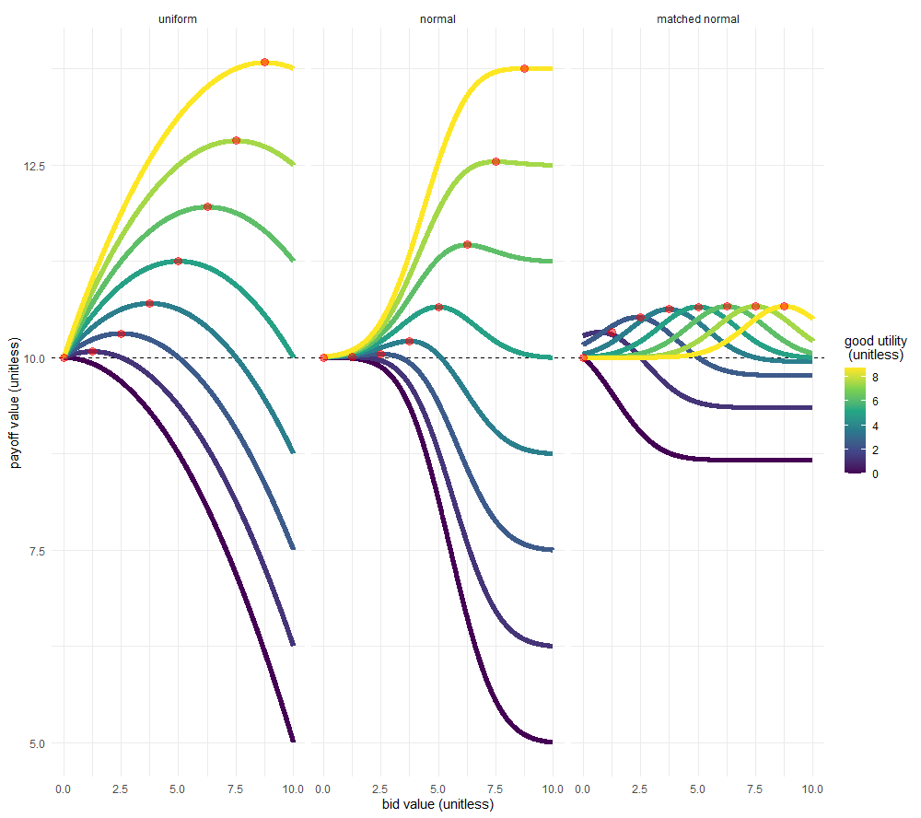
Figure 2.3: The expected payoff for a BDM auction given an initial endowment of 10 utils. Expected payoff is calculated analytically and is the mean total utility received at the end of a trial from a potentially won good and what remains of the initial endowment. Colours of lines indicate the hypothetical known utility of a good and payoff is shown for a range of bids (x axis) and distribution of computer bids. ‘Uniform’ computer bids follow a flat probability density function where the computer is equally likely to make any bid. ‘Normal’ computer bids follow a normal distribution with a mean of 5 (the mean of the endowed bidding range) and a standard deviation of 5/3 (one third of the mean of the endowed bidding range). ‘Matched normal’ computer bids are normally distributed with the same standard deviation but with a mean centred on the hypothetical known utility of a good. In practice a computer following this distribution would use the learnt mean of a monkeys bid for an offered good. Red circles indicate the maximum possible payoff per situation and are found when a participant’s bid is equal to the utility of the good. The dashed black line is at 10 utils, indicating the utility a participant would gain if they could simply keep their endowment and not participate in the auction.
When the computer bid is drawn from a uniform distribution across the bidding range, this chance of winning is equal to the percentage of maximum possible bid that the subject bids, and the expected payment is exactly equal to half of the subjects bid. For any rational bidder who seeks to maximise the payoff for any trial, the greatest possible expected payoff occurs when the good, $G$, being auctioned has a utility $υ_{i}(G)$ = B_{max}, and the smallest possible expected payoff occurs when the good has a utility $υ_{i}$(G) = 0. Such a bidder therefore has an expected payoff on any trial of

Equation 2.5
$$\overline{P}= \left\{\begin{aligned}\frac{3}{2} B_{max}, if υ_{i}(G)= B_{subject} ≥ B_{max} \\ B_{max}, if υ_{i}(G)= B_{subject} = 0 \\ \frac{{B_{subject}}^{2}}{{2B}_{max}} +B_{max}, otherwise\end{aligned}\right.$$

The derivation for these formulae can be found in appendix 2.2.

For an unvalued good, any participant on a BDM trial can simply bid the minimum possible amount to keep the budget and maximise their earnings. If the same bidder later faces the best possible trial (for a good which is valued at the maximum possible bid) they can expect to make a profit of one and a half times the bidding range. Therefore, any hyper-rational participant in the BDM task knows that before any trial the maximum possible amount that a good can change the expected payoff is by half the bidding range- a relatively small incentive given the attention and cognition demanded by the BDM paradigm.

This payoff gradient can also be expressed in an inverse manner as the expected ‘cost of misbehaviour’ for a participant deviating from an optimal bid on a BDM trial. As a comparison to figure 2.3, the cost of misbehaviour of a bid, given the utility of a good and the same distributions of computer bids, is shown in figure 2.4. On the BDM task the expected cost of misbehaviour is obviously zero when a participant bids exactly their internal utility of a good (red circles) and rises as bids deviate from this point.

As figure 2.4 points out, only under very poor bidding does this cost of misbehaviour rise to a significant proportion of initial endowment of 10 utils. Thus, the reinforcing regret signal a monkey might receive when overpaying for a good, or missing out on a potential profit, is weak. There are two implications of this. Firstly, when learning to perform the BDM, monkeys might require intensive training to become reinforced on the optimal strategy. Secondly, that even once trained we might expect both human and non-human bids contain a degree of stochasticity around a true utility for any good.

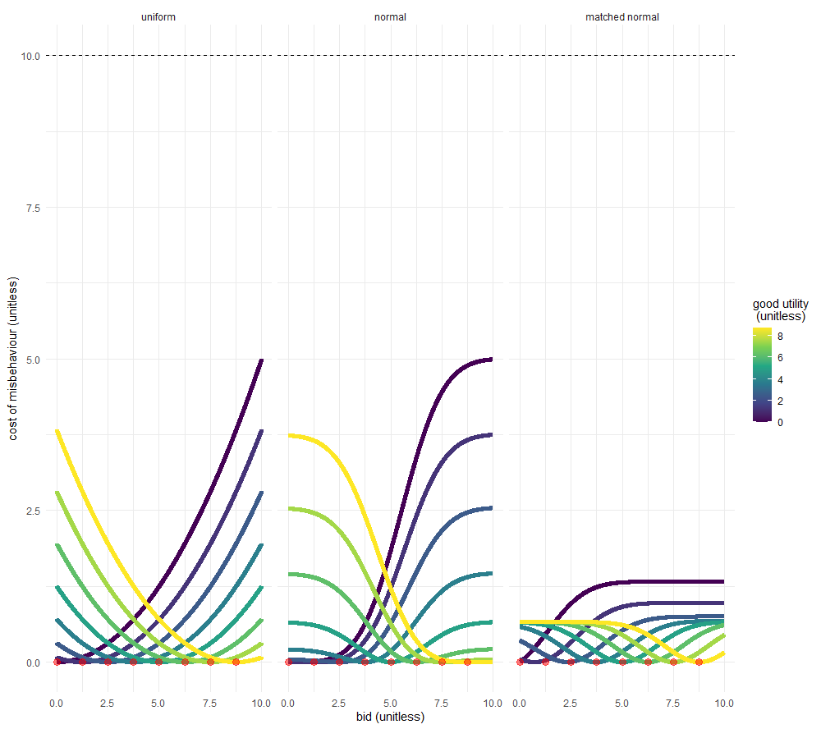
Figure 2.4: The expected cost of misbehaviour in a BDM auction given an initial endowment of 10 utils. Expected cost of misbehaviour is calculated analytically and represents the difference between the expected payoff from a trial given the participants bid, and the expected payoff of a trial where the participant bids optimally (bid == utility). Red circles indicate the cost of misbehaviour for a hyper-rational bidder who always bids their utility and show an expected cost of misbehaviour equal to zero. Colours of lines indicate the hypothetical known utility of a good and payoff is shown for a range of bids (x axis) and distribution of computer bids. ‘Uniform’ computer bids follow a flat probability density function where the computer is equally likely to make any bid. ‘Normal’ computer bids follow a normal distribution with a mean of 5 (the mean of the endowed bidding range) and a standard deviation of 5/3 (one third of the mean of the endowed bidding range). ‘Matched normal’ computer bids are normally distributed with the same standard deviation but with a mean centred on the hypothetical known utility of a good. In practice a computer following this distribution would use the learnt mean of a monkeys bid for an offered good. The dashed black line is at 10 utils, indicating the maximum possible misbehaviour of a participant who refuses to interact with the task and does not get to keep their ‘endowment’.
As the expected payoff and the expected cost of misbehaviour in the BDM task depends upon the computer bid faced by a participant, the selection of an appropriate distribution of opposing bids is important. Figures 2.5a and 2.5b show the expected payoff and cost of misbehaviour for a distribution of possible participant and computer bids for a good of a chosen value (6.25 utils), showing how the shape of these functions are dependent upon the distribution of computer bids. Distributions of computer bid which follow a normal distribution with a mean either at the midpoint of the budget (‘normal’, sky blue) or the utility of a good (‘matched normal’, green), have a sharper cost of misbehaviour as the participant deviates slightly from their optimal bid, though the ‘uniform’ distribution of computer bids (purple) has a greater cost of misbehaviour at extreme outlier bids.

As this difference in cost of misbehaviour is slight between the uniform and normal distributions of computer bid, we decided to use a uniform distribution of computer bids as it provides a greater expected payoff to incentivise the primate per trial, and also for ease of interpreting our neuronal data. A greater behavioural interrogation of the effect of different distributions of computer bid on the bidding behaviour of both human and non-human participants would be an interesting avenue of potential research, though from the literature of human economic studies it’s seems to have little to no effect (Irwin et al., 1998).

The BDM as a neuroscientific task

For the most part, research into the BDM has been undertaken in an economic context, to access a human’s utility function, e.g. to study preference for risk (Safra et al., 1990), or in marketing to elicit usable prices for goods to be later sold (Bohm et al., 1997). We conclude this chapter discussing recent papers studying the neural basis of decision making which have employed the paradigm.

The BDM is especially suited to neuroscientific research where signals of interest change on a moment-to-moment basis as participants make individual choices. For example Grether et al., 2007 use the BDM in a functional magnetic resonance imaging (fMRI) study of humans performing sequential BDM auctions to study the changes in blood-oxygen-level-dependent (BOLD) signal across the brain as subjects learn the best task strategy and converge towards an (‘Nash equilibrium’) optimal bid.

Though this study reports only tentative changes in BOLD activation of brain areas between the ‘learning’ and ‘equilibrium’ phase of the experiment, it shows us three distinct behavioural reasons why we believe the BDM to be a natural paradigm for neuroscientific research:

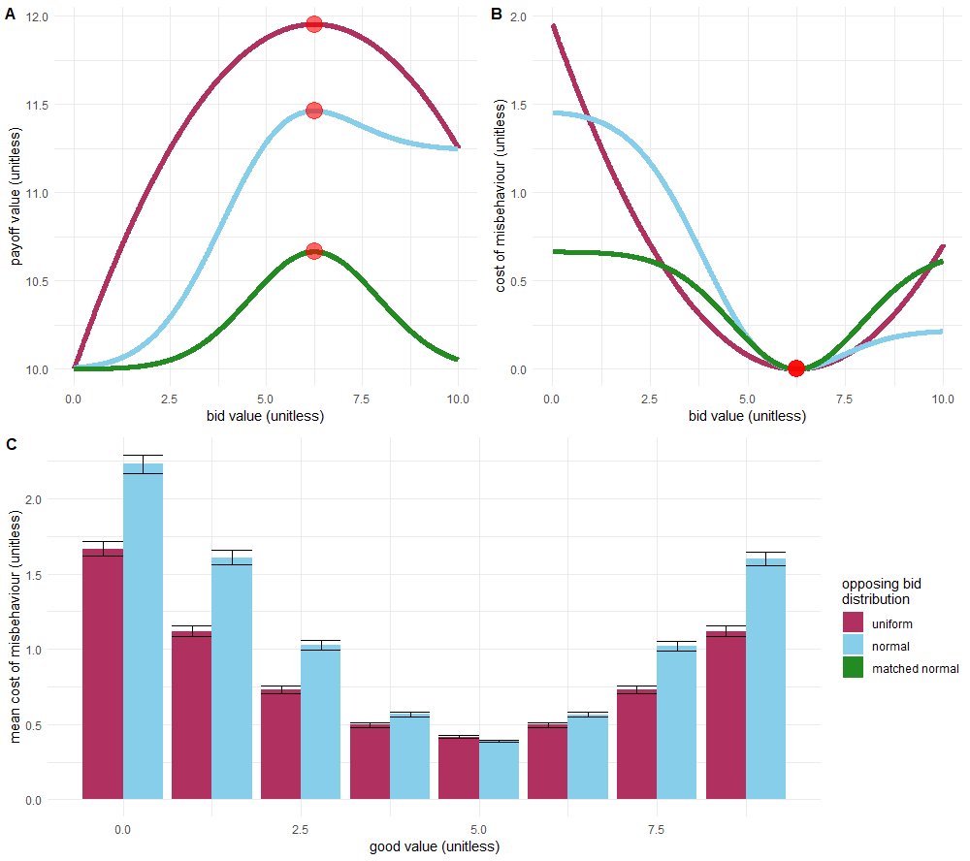
Figures 2.5a-c): How the distribution of computer bids defines the shape of the payoff and cost curves for a good of known utility. In a) and b) a good of known utility of 6.25 utils and show the expected payoff from a BDM auction where a participant is endowed with a budget of 10 utils. Payoffs and cost of misbehaviour are calculated as in figures 2.3 and 2.4. Red circles indicate the maximum payoffs (a) and minimum expected cost of misbehaviour (b). These are observed where the participant bids the exact value of the offered good (6.25 utils). Expected payoff and cost of misbehaviour curves are shown for the three different distributions of computer bids described in figures 2.3 and 2.4. In c) the mean cost of misbehaviour for a monkey which bids uniformly randomly across the endowment budget range is shown for a range of offered good utilities. Colours of bars indicate the opposing computer bid distribution and error bars represent the standard error of the mean. The ‘matched normal’ distribution of bids is not shown in c) as it requires a separate distribution for each given utility of an offered good.
- The BDM is a cognitively demanding task with a rich behavioural output. For each bid, the participant is calculating both the value of the good and the probability of winning or losing the auction, instead of ‘simply’ picking an option. Each small increase in a participants bid contributes to their chance of winning an auction but also their chance of overpaying for a good and so a precise calibration between risk and reward is necessary, even when the auction is for a good with a certain payout. Compare this to the binary choice paradigm where the value offered goods also must be compared but may differ wildly; there are no easy ‘black or white’ choices on the BDM, and instead an animal must choose how much of a budget good to invest in order to achieve a goal (winning the offered good).

Grether et al. report increases in BOLD signal increases in Brodmann’s Area 10 between the two phases of the experiment. Area 10 makes up a significant proportion of the human analogue of the primate medial orbitofrontal cortex which has previously been found to track multiple decision variables including value of the chosen good, the probability of winning the chosen good, and the cost involved with that choice (Kennerley et al., 2009).

- The bidding strategy per subject is clear to see even over only 8 trials; the mean bids of the majority of subjects line up with the known value of the offered good. A binary-choice paradigm requiring the averaging of choices to find an individual’s utility function would almost certainly require at least all 32 choices to be made under the same strategy to find a useful indifference point (e.g see figure 2.7 redrawn from Mosteller and Nogee). Moreover, instead of using multiple trials per combination of offered goods to calculate a precise and accurate indifference point for each in a binary choice paradigm, an experimenter could instead test a greater range of offered goods to generate a richer description of how an animal/brain region/neuron calculates value over a greater sample of contexts.

- The changes in bidding strategy over sets of 8 trials is also plain to see as subjects learn and become familiar with the BDM. Though we might not expect NHPs which have been trained extensively on the BDM task to show such large learning-related changes in strategy, we would expect liquid-controlled animals to show changes in strategy (e.g.) as they become stated with liquid. In the introduction to this thesis we discuss Bernoulli’s formulation of utility theory around the marginal utility of money to an already-rich man. In experiments where animal subjects which receive the good as they bid for/choose it, we might expect sated, non-thirsty animals to ‘spend’ liquid volume to receive a ‘more expensive’ liquid taste. There are myriad reasons why a participant might change their choice/bidding behaviour during an experiment, which could occur over a wide range of timescales, so being able to place each single trial within a context of observed behaviour is crucial. As might be expected, Grether et al. found that these changes in bidding strategy were accompanied by changes in patterns of brain activity measured via the BOLD signal.
The changes in bidding strategy under an intervention were further studied by Medic et al., 2014. Forty-six hungry human subjects in an fMRI machine were shown images of appealing foods and asked to place bids with the chance to win (and eat) the foods directly after a recording session. These subjects were also split into groups of sixteen, each receiving either a dose of a D2 receptor antagonist sulpiride, a D2 receptor agonist bromocriptine, or a placebo. Again, results from this study were relatively weak, without a significant change in mean bids between condition (frustratingly, the intervention means results can only compared between treatment groups and not within single subjects), and though the authors find increases in the BOLD signal in the ventromedial prefrontal cortex, there is no effect of the treatment on this signal.
The findings of Grether et al. and Medic et al., that humans participating in BDM auctions show BOLD activity in the prefrontal cortex has been repeated across further studies (Chib et al., 2009; De Martino et al., 2009; Hare et al., 2008; Plassmann et al., 2007). These findings might be of little surprise; in appendix 1.3 of this thesis we discussed at how single neurons in the orbitofrontal cortex of macaques have been shown to encode economic value (Padoa-Schioppa & Assad, 2006). Though the evidence for differential activity in economic decision-making between vmPFC in humans and OFC in non-human primate studies is confusing (Padoa-Schioppa & Conen, 2017), explanations have been offered as to why this might occur. Wallis, 2012 posits that anatomical differences between species, or differences between the tasks presented might account for the differences in brain region activity.
Perhaps more surprisingly, these studies did not show value correlated BOLD activity in the dopaminergic midbrain. Single dopamine neuron recordings in this area have shown cells to encode the marginal utility of a choice across multiple reward dimensions on a moment to moment basis (Lak et al., 2014; Stauffer et al., 2014). We would expect activity in these neurons to correlate with the with the utility of an offered good (and thus the bid made by a participant), just as activity in the prefrontal cortex seems to.
Some suggestions for why these crucial, utility-signalling neurons might not show up as regions of interest in analysis of the BOLD signal in fMRI studies of human decision making are outlined in D’Ardenne et al., 2008. Midbrain dopaminergic nuclei are extremely small and located near large blood vessels whose pulses create movement artefacts. Even using a simple paradigm of imaging human brains under the expected or unexpected receipt of monetary rewards, only small effect sizes were seen in the change of BOLD signal.
Futhermore, the BOLD signal reported by fMRI is known to have significantly greater variability than electrophysiological recordings at the same location (Logothetis, 2002) and so is not as suitable for studying the sparser density and subtler phasic activity of midbrain dopaminergic neurons. This may in part be because the BOLD signal reflects the synaptic, rather than spiking, activity of neurons (Viswanathan & Freeman, 2007), which may be of considerable interest when studying striatal dopamine signalling where only one third of dopaminergic varicosities may contain the key scaffolding proteins required for release of the neurotransmitter and synaptic signalling (Liu et al., 2018).
Recording the spiking activity of these midbrain dopaminergic cells requires direct access to the brain and precludes recording from humans. By training non-human primates on the BDM task we could overcome the limitations of fMRI and gain direct access to the single-cell neuronal signal of midbrain dopaminergic neurons. In the following chapter we present a task designed to be suitable for primate learning and behvaioural data showing that trained macaques are able to understand the BDM paradigm.
Appendix 2.1- Derivations of payoff and expected cost of misbehaviour on a BDM auction trial
For a more formal proof of the incentive-compatibility of the BDM task, we present a proof, originally adapted from Milgrom & Weber, 1982 in Al-Mohammad & Schultz, 2019. Terms have been edited slightly to reflect their usage in this thesis, but the proof otherwise remains the same.

We assume that any participant has smooth, continuous, and differentiable utility function. An example is shown in figure 2.6, where the red lines shows the expected utility of hypothetical participants for bids increasing along the x axis. The black straight lines show the differentiation of this utility function with respect to bid at certain points along this curve.

We know that the expected utility a participant has is the expected utility of winning the auction multiplied by the probability of winning the auction, plus the expected utility of losing the auction multiplied by the chance of losing the auction.

Equation 2.6
$$υ_{i}\left(\overline{P}\right)=p_{win}⋅υ_{i}\left(\overline{P}|win\right) + (1 - p_{win})⋅υ_{i}\left(\overline{P}|loss\right)$$

In the main text of Chapter 2, and in appendix 2.2 we discuss the closed form solutions to this expected utility when participants make bids against one computer randomly drawing its bid from a uniform distribution. Here we consider a participant bidding in a ‘life-like’ auction where a participant bids against any number of other bidders with unknown utility functions of their own.

This participant places a bid, $B_{subject}$, which determines whether they win an auction against any number of other bids $B_{opps}$, where the maximum of these, ${\hat{B}}_{opps}$ determines the price paid in the event of the participant winning the auction. The probability of winning or losing any auction trial is therefore a cumulative distribution function of the opposing bids, $f$($B_{subject}$) bounded by the minimum possible bid, $B_{min}$, and the subjects bid.

Equation 2.7
$$υ_{i}\left(\overline{P}\right)=\int_{B_{min}}^{B_{subject}}{υ_{i}\left(\overline{P}|win\right)f({\hat{B}}_{opps})d{\hat{B}}_{opps}+ \int_{B_{subject}}^{B_{max}}{υ_{i}\left(\overline{P}|loss\right)f({\hat{B}}_{opps})d{\hat{B}}_{opps}}}$$

As we are considering auctions as commonly understood in the marketplace (and not as carried out in economic/psychological/neuroscientific contexts), we assume that the utility $U\left(\overline{P}|loss\right)$ is zero; the participant neither wins, nor pays anything for an auctioned good.
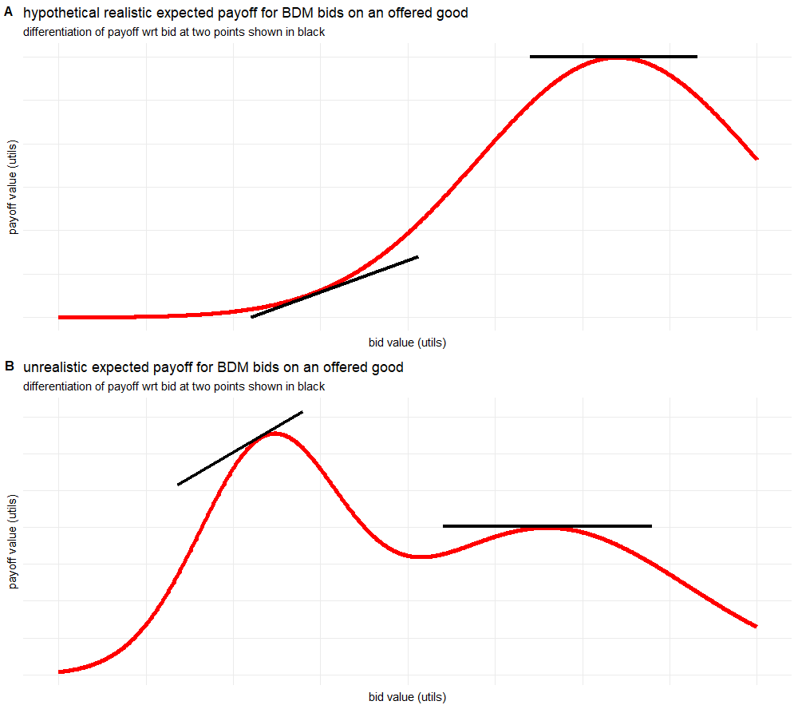
Figures 2.6a-b): Examples of smooth, continuous, differentiable utility functions for expected payoff vs. bid. In a) a realistic utility function for the simple BDM paradigm used in this thesis is shown. This is directly comparable to those found in figure 2.3, especially those for the uniform distribution. Differentiation of the curve is shown in black lines at two points, one at a maxima (the optimal bid as shown in the derivation in this appendix), and one which is not at an optimal bid. In b) we present a hypothetical utility curve for some more complicated paradigm (or indeed a participant who does not understand the paradigm presented). This is not a utility curve we would expect to encounter in the scope of this thesis, but is used to make the point that the proof above will still find local maxima or minima for a subjects utility function. Again, the derivative of the curve is shown at two points, including at one local maxima. Curves are for illustrative purposes and so are valueless across both axes.

$$υ_{i}\left(\overline{P}\right)=\int_{B_{min}}^{B_{subject}}{υ_{i}\left(\overline{P}|win\right)f({\hat{B}}_{opps})d{\hat{B}}_{opps}+ \int_{B_{subject}}^{B_{max}}{0 f({\hat{B}}_{opps})d{\hat{B}}_{opps}}}$$

$$υ_{i}\left(\overline{P}\right)=\int_{B_{min}}^{B_{subject}}{υ_{i}\left(\overline{P}|win\right)f({\hat{B}}_{opps})d{\hat{B}}_{opps}}$$

The expected utility of the payoff, given that the participant wins the auction is equal to the utility of the won good ($G$), minus the payment for the good

$$υ_{i}\left(\overline{P}\right)=\int_{B_{min}}^{B_{subject}}{υ_{i}\left(G - {\hat{B}}_{opps}\right)f({\hat{B}}_{opps})d{\hat{B}}_{opps}}$$

The maximum utility to a participant, $U\left(\overline{P}\right)$, occurs when the first derivative of their expected utility with respect to their own bid $B_{subject}$ is zero. At exactly this point, the change to their utility as they change their bid is zero. Moving their bid to either side of this point causes the change to utility with respect to the bid to become negative.

Equation 2.8
$$\frac{dυ_{i}\left(\overline{P}\right)}{dB_{subject}}=υ_{i}\left(G - B_{subject}\right)f(B_{subject}) = 0$$

It is clear that this equation is satisfied when the brackets of the utility function are equal to zero, that is, when the value of the good$G$ in units of the budget is equal to $B_{subject}$. In other words, this maxima is found when the utility of a good is exactly matched by the utility of the budget bid by a participant; a subject maximises utility by bidding exactly their utility for a good.

For a graphical representation of this proof, see figure 2.3 where the change in payoff value (in utils) is flat with respect to the bid, at the point where the bid is equal to the utility of the auctioned good (red circles).

Appendix 2.2- Derivations of payoff and expected cost of misbehaviour on a BDM auction trial

For any economic decision making task the payoff is equal to the magnitude of potential outcomes, multiplied by the probability of that outcome occurring (equation 1.2). In any auction task there are only two outcomes: winning the auctioned good, or not. As the BDM is a second price auction, a ‘win’ occurs when the participant makes the highest bid, and the outcome is that they receive the auctioned good and pay the second highest bid out of their budget. The expected utility of a payout $υ_{i}(P)$ can therefore be expressed as:

Equation 2.9
$$υ_{i}\left(\overline{P}\right)=p_{win}⋅\left(υ_{i}\left(G\right)+\left(Budget-{\overline{B}}_{computer|win}\right)\right) + (1 - p_{win})⋅Budget$$

Where a good $G$, of some utility in terms of the budget is auctioned and receives bids, $B$.

We use a BDM task as commonly reported in the economics literature where there is one opponent bidder- a computer who makes random bids with an equal, uniform probability across the entire bidding range. The probability of a participant winning any auction trial is therefore equal to their bid as a fraction of the total bidding range.

$$υ_{i}\left(\overline{P}\right)=\frac{B_{subject}}{Budget}⋅\left(υ_{i}\left(G\right)+\left(Budget-{\overline{B}}_{computer|win}\right)\right) + (1 - \frac{B_{subject}}{Budget})⋅Budget$$
In the BDM paradigm, both subjects and the random computer bid are drawn from a range from 0 to the total of the Budget, so the maximum bid is exactly equal to the Budget for any trial:
$$υ_{i}\left(\overline{P}\right)=\frac{B_{subject}}{B_{max}}⋅\left(υ_{i}\left(G\right)+\left(B_{max}-{\overline{B}}_{computer|win}\right)\right) + (1 - \frac{B_{subject}}{B_{max}})⋅B_{max}$$

The expected computer bid given that the computer has bid less than $B_{subject}$ is a random bid drawn uniformly from the range of 0-$B_{subject}$. The average computer bid on a trial that the subject wins is therefore half of $B_{subject}$:
$$υ_{i}\left(\overline{P}\right)=\frac{B_{subject}}{B_{max}}⋅\left(υ_{i}\left(G\right)+\left(B_{max}-\frac{B_{subject}}{2}\right)\right) + (1 - \frac{B_{subject}}{B_{max}})⋅B_{max}$$

We can now multiply out the brackets to reduce this equation to:
Equation 2.10
$$υ_{i}\left(\overline{P}\right)= \frac{υ_{i}\left(G\right){⋅B}_{subject}}{B_{max}} +B_{subject}- \frac{{B_{subject}}^{2}}{2B_{max}} +(B_{max} - B_{subject})$$

$$υ_{i}\left(\overline{P}\right)= \frac{υ_{i}\left(G\right){⋅B}_{subject}}{B_{max}} - \frac{{B_{subject}}^{2}}{{2B}_{max}} +B_{max}$$

The BDM is incentive compatible for each trial, therefore on each trial a rational participant should seek to maximise the utility of their expected payout by bidding exactly their utility for the good $G$. I.e. we assume for any trial that $υ_{i}(G) = B_{subject}$.
$${υ_{i}\left(\overline{P}\right)}_{max}= \frac{B_{subject}{⋅B}_{subject}}{B_{max}} - \frac{{B_{subject}}^{2}}{{2B}_{max}} +B_{max}$$
$${υ_{i}\left(\overline{P}\right)}_{max}= \frac{{B_{subject}}^{2}}{B_{max}} - \frac{{B_{subject}}^{2}}{{2B}_{max}} +B_{max}$$
$${υ_{i}\left(\overline{P}\right)}_{max}= \frac{{B_{subject}}^{2}}{{2B}_{max}} +B_{max}$$

As mentioned, $B_{subject}$ is in the range 0-$B_{max}$. We can therefore $B_{subject}$ express in terms of $B_{max}$ for the ideal situation for any subject (a highly valued good to be auctioned when $υ_{i}(G) = B_{subject}≥B_{max}$), or the worst case (an unvalued good when $υ_{i}(G) = B_{subject} = 0$).

For any trial we can therefore express the expected utility of the payoff for a monkey to be:
Equation 2.1110
$${υ_{i}\left(\overline{P}\right)}_{max}= \left\{\begin{aligned}\frac{3}{2} B_{max}, if υ_{i}(G) = B_{subject} ≥ B_{max} \\ B_{max}, if υ_{i}(G) = B_{subject} = 0 \\ \frac{{B_{subject}}^{2}}{{2B}_{max}} +B_{max}, otherwise\end{aligned}\right.$$

From this result, we can trivially derive the expected cost of misbehaviour- the difference between the maximum expected payoff of a trial and the post-bid expected payoff of a trial. As misbehaviour will only affect the potential profit of a trial, for simplicity’s sake we only consider the difference between the utilities of expected profit ($\overline{π}$). The expected change in payout between when the participant bids their utility ($υ_{i}(G) = B_{subject}$) and when they do not ($υ_{i}(G) ≠ B_{subject}$).

Equation 2.112
$$υ_{i}\left(\overline{π}\right)=\frac{B_{subject}}{B_{max}}⋅\left(υ_{i}\left(G\right) - \frac{B_{subject}}{2}\right)$$

$$υ_{i}(ECM)= {υ_{i}\left(\overline{π}\right)}_{max} - υ_{i}\left(\overline{π}|B_{subject}\right)$$

For when the participant actually misbehaves this can also be written as

$$υ_{i}(ECM)= υ_{i}\left(\overline{π}|B_{subject} = υ_{i}(G)\right)- υ_{i}\left(\overline{π}|B_{subject} = φ_{i}(G)\right)$$

Where $φ_{i}(G)$ is the utility function for a good $G$ which incorporates some error, deviating the bid from the optimal value.

Equation 2.13
$$υ_{i}(ECM) = \frac{{υ_{i}(G)}^{2}}{{2B}_{max}} - \left(\frac{υ_{i}\left(G\right) ⋅φ_{i}(G)}{B_{max}} - \frac{φ_{i}{(G)}^{2}}{{2B}_{max}}\right)$$

$$υ_{i}(ECM)= \frac{{υ_{i}(G)}^{2}}{2} + \frac{{φ_{i}(G)}^{2}}{2} - υ_{i}\left(G\right) ⋅φ_{i}(G)$$

$$υ_{i}(ECM)= \frac{{(υ_{i}\left(G\right) - φ_{i}(G))}^{2}}{2}$$
If we express the difference between $υ_{i}\left(G\right)$ and $φ_{i}(G)$ as some error $ε$, we can then rewrite this as

Equation 2.14
$$υ_{i}(ECM)= \frac{ε^{2}}{2}$$

Therefore, the actual utility of a good, U(G), has no effect per se on the cost of misbehaviour to the participant. Instead, it is only the deviation from this utility which affects the disutility of suboptimal bidding.

For fuller discussions of deriving the payoff and cost of misbehaviour for the BDM, extending this appendix to multiple bidders and more complex distributions of computer bid, see Lusk et al., 2007.

See appendix 1.1 on Prospect theory which goes into further detail on the subjective treatment of probabilities in utility theories.
It is also possible that the player may simply not realise the correct value of their hand. Especially (but not limited to!) animal work it is impossible to perfectly verify if a subject understands a task so the simplicity of a task and its strategies is important to take into account.
See previous chapter on organism’s behaviour as utility maximising
We leave out the possibility that more of a good could contain disutility here. The current year however provides many examples that run counter to rigid economic thought. See Kubursi, 2020 for an example of negative prices for oil futures contracts.
This is also equivalent to tasks in which a good A and a good B are presented with probabilities x and y, which for the sake of brevity is also left out here.
See for instance the difference between being willing to pay more for a coffee on mornings where you had less sleep, and ‘choosing’ to buy a style of coffee you don’t like because you are too tired to communicate your choice to a barista. The idea behind stochastic choice theory is explained in greater detail in appendix 1.1.
Throughout this chapter, and the rest of the thesis, we will carry forward the assumption that any bid made is equal to the utility of the good to the primate making that bid. Of course, as with any behavioural paradigm this isn’t strictly 100% true even if the monkey had full information about the task (see Grether et al., 2007); a stricter definition would be that we expect the primates to bid their utility for the good, plus their utility for making the ‘correct’ bid plus some stochastic error (e.g. even well trained humans playing video games make joystick errors).
Though see previous section that in experimental paradigms the subject ‘gains’ the endowed budget in a lost auction trial.
Though see Hamukwala et al., 2019, which supposes that the complexity of the BDM means that even humans require extensive practice to produce reliable bidding.
Our monkeys cannot be told an induced value but should quickly learn the constant and certain value of an offered liquid good upon winning auctions.
A possibly counterintuitive idea. The expected computer bid before any bidding takes place is of course equal to half the maximum possible bid, however this is the expected computer bid given we know the subject won the auction. See the Monty Hall problem for a similar example.
Any good $G_{a}$ where $υ_{i}(G_{a})$ > B_{max} is indistinguishable from a good $G_{b}$ where $υ_{i}(b)$ == B_{max} and so the BDM paradigm is not a suitable task for such goods.
Though 16 bids are made in each of the ‘learning’ and ‘equibilibrium’ phases of the experiment, these are further split into four sets of 8 bids in the authors reporting.
See for instance, Dabney et al., 2020 on how the response activity of a single dopaminergic neuron is not simply a linear function of the magnitude of a reward. The more contexts (e.g. the greater distribution of reward magnitudes encountered) a neuron is recorded under, the greater the resolution of its scaling function. C.f. figure 4b) of Dabney et al., where the 7 magnitudes of possible reward mean (at most) fitting a scaling function to 3 or 4 (i.e. half of the) encountered reward magnitudes.
Mean bids were slightly, but not significantly higher in the sulpiride condition than in either the bromocriptine or placebo condition, raising the interesting possibility that it may be possible for interventions to affect bidding behaviour. It is perhaps confusing why a D2 antagonist (i.e. and inhibitory effect on an inhibitory signal) might affect behaviour in this way, though the authors make the point that it may simply be because application of sulpiride increases the variability of bids so they regress towards the mean of the budget range.
The main finding of this paper was the effect of treatment on the BOLD signal in the intraparietal sulcus, especially during the ‘late’ stage of valuation (more than half the time from stimulus presentation to setting one’s bid). Activity within this area has previously been implicated in decision making tasks with signals correlating with the gain a subject expects from a trial (Platt & Glimcher, 1999).
In rare cases it is possible to record electrophysiological signal from the human brain. See Zaghloul et al., 2009 for one such example, recording from the substantia nigra in patients undergoing deep-brain surgery for Parkinson’s disease.
This of course makes no difference, we are simply using the proof as formulated by Milgrom and Weber. In the BDM as discussed in the body of this thesis we assume there to be some utility just from receiving the endowment gifted to the participant at the start of each trial, but this utility should be ‘baked in’ to the participants expected payoff and so does not change the results, or implications, of the derivation here. It is actually probably untrue that the utility even of human’s buying and selling mineral rights (the example in Milgrom and Weber, 1982) is zero (see below).
This assumption is economically sound, but probably psychologically tenuous. Consider a child on Christmas Day who has spent the last six months expecting a specific gift and instead receives nothing.
Figure 2.6b) does in fact have a local minima at roughly the mid-point of the x-axis which contradicts this. A more stringent proof would state that this maxima is only a local maxima. For complicated utility functions that might arise (e.g.) as the BDM task is extended and extra round of bidding/payments/chance are incorporated this could become important. For the simple BDM paradigm in this thesis and in the lifelike auctions of Milgrom and Weber we assume a ‘simple’ utility curve with only one maxima as presented in figure 2.6a) and figure 2.3.
In the event of a loss the payoff is the same regardless of whether a participant paid attention- they receive the full endowment.

